|  |  |  |  |
| --- | --- | --- | --- |
| Portfolio Risk Analysis | | |  |
| **Metric** | **Weekly** | **Monthly** | **Annualized** |
| Alpha |  |  |  |
| Active Risk |  |  |  |
| Portfolio Risk |  |  |  |
| Portfolio Return |  |  |  |
| Benchmark Risk |  |  |  |
| Benchmark Return |  |  |  |
| Portfolio Beta |  |  |  |
| Tracking Error/  Active Risk |  |  |  |
| Information Ratio |  |  |  |

**VaR Sensitivity Chart** (example)

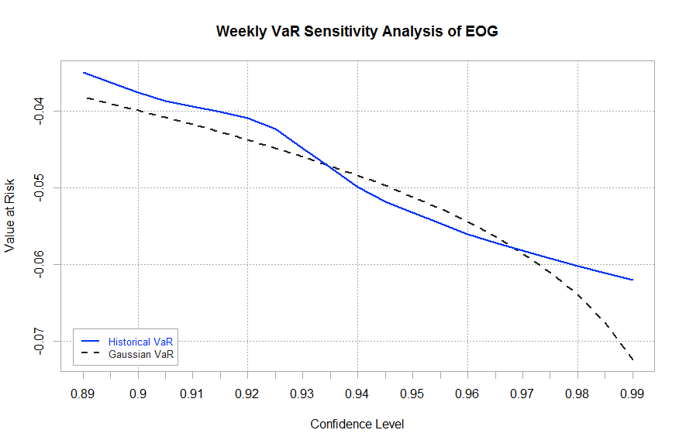

**Sector Break-Down**, (S&P vs HHIC)

**Performance Summary**



(Tarang and Haroon)

|  |  |  |  |  |  |  |  |
| --- | --- | --- | --- | --- | --- | --- | --- |
| **Top 10 In-depth Holdings (Since Inception)** | | | | | | | |
| Asset | Ticker | Sector | P/L | Return | Volatility | Active Weight (% of total portfolio) | Contribution to Tracking Error (%) |
| AGRIUM INC |  |  |  |  |  |  |  |
| CATAMARAN CORP |  |  |  |  |  |  |  |
| GENERAL MILLS |  |  |  |  |  |  |  |
| GOLDM SACHS GRP |  |  |  |  |  |  |  |
| JPMORGAN CHASE |  |  |  |  |  |  |  |
| SCHLUMBERGER LTD |  |  |  |  |  |  |  |
| STRATASYS LTD |  |  |  |  |  |  |  |
| SUNCOR ENERGY |  |  |  |  |  |  |  |

Note active weight = portfolio weight – benchmark weight

Tarang and Haroon is responsible for this panel

**Forecasts**

Forecasted Volatility (Using GARCH) – individual and portfolio

Forecasted Return – individual and portfolio   
(based on Bayesian Inference analysis of HHIF analysts)

Richard and Kevin is responsible for this panel

**Forecasts**

Historical Correlations- only display ones that are significant

(Example)

|  |  |  |  |  |  |  |  |  |
| --- | --- | --- | --- | --- | --- | --- | --- | --- |
| **Significant Historical Correlations** | | | | | | | | |
|  | AGRIUM INC | CATAMARAN CORP | GENERAL MILLS | GOLDM SACHS GRP | JPMORGAN CHASE | SCHLUMBERGER LTD | STRATASYS LTD | SUNCOR ENERGY |
| AGRIUM INC | 1 | 0.11 | 0.03 | 0.4 | 0.34 | 0.45 | 0.32 | 0.44 |
| CATAMARAN CORP | 0.11 | 1 | 0.01 | 0.13 | 0.14 | 0.14 | -0.04 | 0.2 |
| GENERAL MILLS | 0.03 | 0.01 | 1 | 0.11 | 0.02 | 0 | 0 | -0.04 |
| GOLDM SACHS GRP | 0.4 | 0.13 | 0.11 | 1 | 0.73 | 0.53 | 0.2 | 0.55 |
| JPMORGAN CHASE | 0.34 | 0.14 | 0.02 | 0.73 | 1 | 0.54 | 0.22 | 0.53 |
| SCHLUMBERGER LTD | 0.45 | 0.14 | 0 | 0.53 | 0.54 | 1 | 0.35 | 0.69 |
| STRATASYS LTD | 0.32 | -0.04 | 0 | 0.2 | 0.22 | 0.35 | 1 | 0.33 |
| SUNCOR ENERGY | 0.44 | 0.2 | -0.04 | 0.55 | 0.53 | 0.69 | 0.33 | 1 |

Forecasted Correlations (Using GARCH) -only display ones that are significant

Richard and Kevin is responsible for this panel

**Attribution Analysis**

Hudson

**Stress Test**

(example)

Please conduct stress test vs the Markets, Interest Rates, Commodity (use some sort of aggregate index like the UBS Commodity index), sector stress test, barra style test (do this after Hudson is finished the attribution analysis

Richard

ADD MARGINAL CONTRIBUTION TO ACTIVE RISK(MCAR)  
MACHINE LEARNING STRATEGIES (momentum –BlackRock Paper, google search words)